a) Formation of Neural Network for OR, AND using Threshold function

Traincontroller.java

package controller;

import model.Train;
import service.TrainService;

import javax.servlet.ServletException;
import javax.servlet.annotation.WebServlet;
import javax.servlet.http.HttpServlet;
import javax.servlet.http.HttpServletRequest;
import javax.servlet.http.HttpServletResponse;
import java.io.IOException;
import java.sql.SQLException;

@WebServlet(name = "TrainServlet")
public class TrainController extends HttpServlet {
protected void doPost(HttpServletRequest request, HttpServletResponse response) throws ServletException, IOException {
Train train;
int[][] input = new int[2][4];
for(int i=0;i<2;i++){
for(int j=0;j<4;j++){
input[i][j] = Integer.parseInt(request.getParameter("input"+i+j));

}
}
/*for(int i=0;i<2;i++){
for(int j=0;j<4;j++){
System.out.println(input[i][j]);
}
}*/
float[] weight = new float[2];
for(int i=0;i<2;i++){
weight[i] = Float.parseFloat(request.getParameter("initweight" + i));
}
/*for (float x : weight){
System.out.println(x);
}*/
train=new Train(input,weight);

TrainService service = null;
try {
service = new TrainService();
} catch (Exception e) {
e.printStackTrace();
}

Train trained = service.calculateWeight(train);

float[] finWeight=trained.getWeights();
int it=trained.getIt();

try {
service.storeWeights(finWeight);
} catch (SQLException e) {
e.printStackTrace();
}

/*System.out.println(finWeight[0]);
System.out.println(finWeight[1]);*/

request.setAttribute("weight1",finWeight[0]);
request.setAttribute("weight2",finWeight[1]);
request.setAttribute("iter",it);
request.getRequestDispatcher("/view/train.jsp").forward(request,response);
}

protected void doGet(HttpServletRequest request, HttpServletResponse response) throws ServletException, IOException {

}
}

Testcontrolelr.java

package controller;

import model.Test;
import service.TestService;

import javax.servlet.ServletException;
import javax.servlet.annotation.WebServlet;
import javax.servlet.http.HttpServlet;
import javax.servlet.http.HttpServletRequest;
import javax.servlet.http.HttpServletResponse;
import java.io.IOException;

@WebServlet(name = "Test1Controller")
public class TestController extends HttpServlet {
protected void doPost(HttpServletRequest request, HttpServletResponse response) throws ServletException, IOException {
TestService service = null;
Test weights = null;
try {
service = new TestService();
weights=service.getWeights();
} catch (Exception e) {
e.printStackTrace();
}

if (weights.getWeight()[0]==0){
request.getRequestDispatcher("/index.jsp").forward(request,response);
}
else {
int[] input = new int[2];
String valid = request.getParameter("input0");

if(valid==null){
request.getRequestDispatcher("view/test.jsp").forward(request,response);
}
else{
for(int i=0;i<2;i++){
input[i] = Integer.parseInt(request.getParameter("input"+i));
}
float[] weight = weights.getWeight();
//System.out.println(weights);
weights = new Test(input,weight);
//System.out.println(weights);
Test output=service.calculateOutput(weights);

//System.out.println(output.getOutput);
request.setAttribute("output",output.getOutput());
request.setAttribute("error",output.getError());
request.getRequestDispatcher("/view/testOutput.jsp").forward(request,response);
}
}
}

protected void doGet(HttpServletRequest request, HttpServletResponse response) throws ServletException, IOException {
//System.out.println("hoho");
doPost(request,response);
}
}

TestService.java

package service;

import model.Test;

import java.sql.Connection;
import java.sql.ResultSet;
import java.sql.SQLException;
import java.sql.Statement;

public class TestService {
private Connection connection = null;
private ResultSet resultSet = null;
private Statement statement;
private String query;
private Test result = new Test();

public TestService() throws Exception{
connection = new Database().getDbConnection();
statement = connection.createStatement();
}

public Test getWeights() throws SQLException {
float[] weights = new float[2];
query="select * from andweights";
resultSet=statement.executeQuery(query);

while (resultSet.next()){
weights[0]=resultSet.getFloat("weight1");
weights[1]=resultSet.getFloat("weight2");
}
System.out.println(weights[0]+" "+weights[1]);
Test weight = new Test(weights);
return weight;
}

public Test calculateOutput(Test test){
int t=0;
float out=0;
int[] inp = test.getInput();
float[] wt = test.getWeight();

for (int i = 0; i <2 ; i++) {
out+=wt[i]+inp[i];
}
for (int i = 0; i <2 ; i++) {
if (inp[i]<0) {
t=0;
break;
}
else {
t=1;
}
}
float error=(t-out);

result = new Test(t,error);

return result;
}
}

TrainService.java

package service;

import model.Train;

import java.sql.Connection;
import java.sql.ResultSet;
import java.sql.SQLException;
import java.sql.Statement;

public class TrainService {
private Connection connection = null;
private ResultSet resultSet = null;
private Statement statement;
private String query;
private Train train = new Train();

public TrainService() throws Exception{
connection = new Database().getDbConnection();
statement = connection.createStatement();
}

public void storeWeights(float[] weights) throws SQLException {
query="delete from andweights";
statement.execute(query);
query="insert into andweights(weight1,weight2) values("+weights[0]+","+weights[1]+")";
statement.execute(query);
connection.close();
}

public Train calculateWeight(Train inputs){
float out;
int[] y = new int[4];
int[] t={1,1,1,0};
boolean valid = false;
int[][] input = inputs.getIp1();
float[] weight = inputs.getWeights();

for(int i=0;i<10000;i++) {
for(int j = 0; j<4; j++) {
out=0;
for(int k =0; k<2;k++){
out += input[k][j] * weight[k];
}
y[j] = out >= 1 ? 1 : 0;
/*System.out.println("y["+j+"]=="+y[j]);*/
}
for(int j=0;j<4;j++){
if(t[j]==y[j]){
valid =true;
}
else{
valid =false;
break;
}
}
if(valid){
/*for(int j=0;j<4;j++){
//System.out.println("y["+j+"]=="+y[j]);
System.out.println(" y["+j+"]=="+y[j]+" t["+j+"]=="+t[j]+" weight["+0+"]=="+weight[0]+" weight["+0+"]=="+weight[1]);
}*/
break;
}
else{
train.incrIt();
adjustWeight(weight);
}
//-----------------------------------
}
Train trained=new Train(train.getIt(),weight);
return trained;
}

private void adjustWeight(float w[]){
int k;
for(k=0;k<2;k++){
if(w[k]>=1){
w[k]-=0.5;
}
else{
w[k]+=0.1;
}
}
}

}

View-UI:

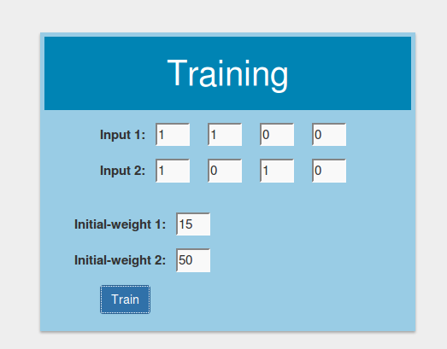Inputs

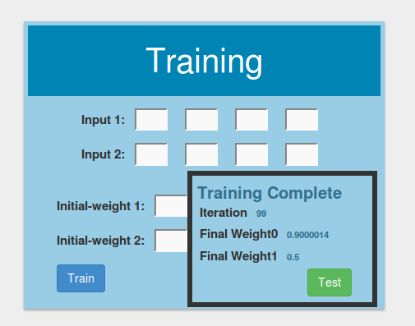Training Complete

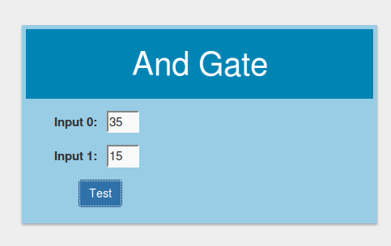Test for any imput

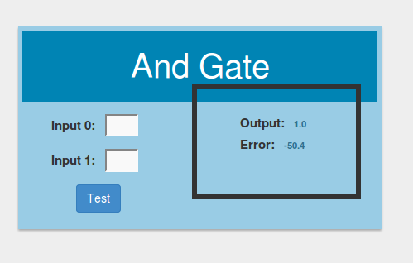OutputGenerated

